-ITINERARY-
Departure: LFU to PBH
What is PBH?
Arrival: Bhutan

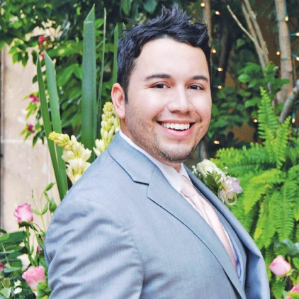

Hello:
I am a K-12 Digital Learning Specialist for the Los Fresnos Consolidated Independent School District, Texas, USA. I'm a published Author, Poet, and avid Photographer. My Doctoral studies have taken me backpacking in the lush jungles of Honduras, trekking across through a chandeliered Hall of Mirrors at the Palace of Versailles, walking among deer in the island of Itsukushima, more known as Miyajima (Shrine Island).
I live on South Padre Island, off the Southern Gulf Coast of Texas. The importance of travel and education is truly a gift that I would love to share with you. I will always be an English 4 AP/Dual, Technology Applications, and Film teacher. Global (Ed)Ventures is a way of taking your students to another part of the world without leaving your classroom.
Find out more information on my website at VirtualRealia.com
Your Digital Falcon ,
Jesse Garza

